Expats Discover Credit Scores Don’t Travel Well

Some find keeping U.S. credit cards helps, but lack of international standards hinders larger purchases
By CHARLIE WELLS, WSJ.com, April 12, 2015 11:02 p.m. ET, also 4/13/15, p. R9
There is one valuable that even highly paid U.S. expatriates struggle to carry with them when they move overseas: their credit score.
People accustomed to high credit limits and premium financial products in the U.S. can be in for a rude surprise when they try to set up house abroad. Some say they have been stunned to find themselves unable to secure the most basic credit required for housing, cars and credit cards.
When expats arrive in foreign countries, most expect to open a local bank account to help them get settled. But most countries’ banking systems won’t consider the numeric credit scores that banks in the U.S. use to evaluate creditworthiness. Most have their own methods and evaluation systems, and some countries penalize residents who haven’t voted in local elections, even though most expats can’t vote. Banks can check this information when they carry out credit checks.
Building this trust takes a lot of care and feeding that locals have been doing for years. For expats, this often means starting from scratch, applying for basic credit cards and bank accounts, slowly building a local credit report. In some countries, it can take years—even becoming a citizen—to access a country’s full range of credit options, like getting a mortgage.
“Credit scores are highly regulated,” says David Kuenzi, a wealth manager based in Madison, Wis., who works with U.S. expat families. Scores are “based upon government regulation and standards agreed upon between banks and reporting companies, and generally those agreements are done at a national level,” Mr. Kuenzi explains. “It can really be a pain.”

Platinum bust
Alex Carey was living in Norwalk, Conn., and making around $250,000 a year working for an online advertising firm when he was promoted to an executive position in London. He needed to make the move with his family quickly, but upon arriving in the U.K. in 2011, he says he was surprised to find that the credit he had established with his platinum American Express card did not move with him. A lack of British credit made it difficult for him to buy a home or car.
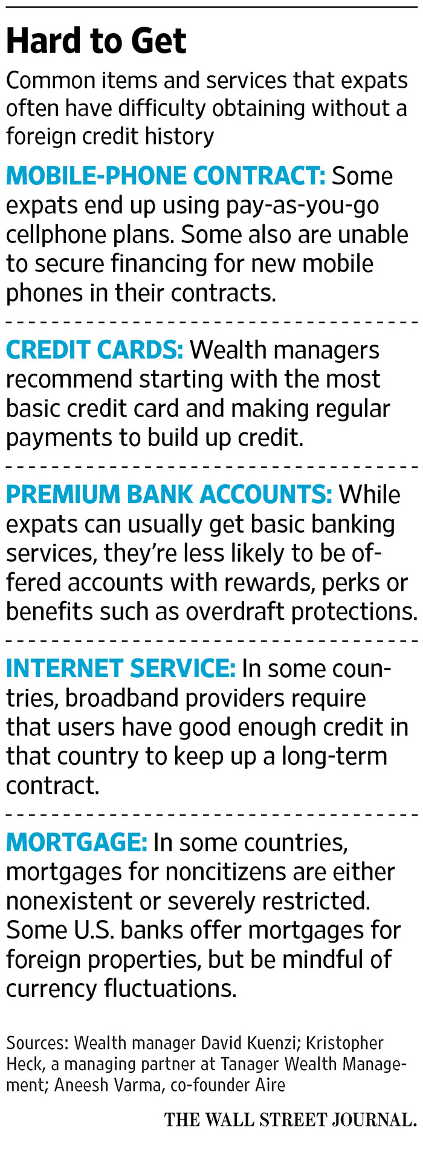
Mr. Carey, 33, owned a house in Connecticut, so he figured securing housing in London would be straightforward. But to sign a lease on an apartment in England, he says he was told he would be subjected to a background check in addition to verification of his salary and banking activity. Just opening a new bank account took three months, he says. And there was no way for him to ride on the credit he had built from his U.S. home equity.
The family also needed a car. But, again, without U.K. credit, he says, he couldn’t get a car loan. He ended up paying in cash for what he calls “a beater,” a 2004 Renault Scenic, which he says cost £2,000 (about $2,960).
“We’ve been living in the U.K. for around 3½ years and have just learned to pay cash for things,” Mr. Carey says.

Plastic advantage
But for other Americans moving abroad, don’t be too quick to leave the plastic at the border. Indeed, for those planning to live abroad long term, financial advisers say keeping a U.S. credit card is one of the simplest ways to maintain a line of credit at home. Experts recommend making small, fairly regular transactions to keep these accounts active and up-to-date.
Tara Yip-Bannicq, a 30-year-old consultant currently based in Bangkok, says she has held a U.S. credit card for much of her adult life to keep a reasonable credit score in the U.S., where she is a citizen. While Ms. Yip-Bannicq has been living overseas for the past 20 years, she says, she keeps up on her credit-card payments fastidiously, and pays her U.S. taxes.
But even maintaining a line of U.S. credit isn’t a cure-all for expats. Recently, Ms. Yip-Bannicq wanted to refinance a U.S. student loan, she says, but was told that because of her credit, she would need a guarantor.
“It’s a bit of a shock when you’re over 30 to find that you need a guarantor,” says Ms. Yip-Bannicq, who adds she thinks that the guarantor issue was the result of her living abroad for such a long period.

Watch the fees
Some expats who can’t easily get foreign credit cards continue to use their domestic cards for the majority of purchases. Tom Feltner, director of financial services at the Consumer Federation of America, recommends watching out for even small international transaction fees on purchases. “Those can range 2% to 3%, which might seem small, but ultimately can dramatically increase cost of borrowing,” he says.
Many companies offer cards for frequent travelers without the fees.
Keep an eye on the card’s exchange rate, too, says Kristopher Heck, a managing partner at Tanager Wealth Management, a London firm that offers financial planning for trans-Atlantic households. A U.S. credit card with a less-than-ideal exchange rate can dramatically raise borrowing costs.
For expats planning to stay in a particular country for the long term, Mr. Heck recommends building local credit early. One method, he says, is to obtain a credit card from a local retail store with a high interest rate.
“Use it once a month,” he says, “and slowly see your credit build with a trickle of transactions.”
Mr. Wells is a news editor for The Wall Street Journal in London. He can be reached atcharlie.wells@wsj.com.

