ECB Unveils Stimulus to Boost Economy

European Central Bank to Purchase €60 Billion in Assets Each Month Starting in March
By BRIAN BLACKSTONE And PAUL HANNON, WSJ.COM, Updated Jan. 22, 2015 11:10 a.m. ET
FRANKFURT—The European Central Bank said Thursday it plans to purchase over €1 trillion ($1.157 trillion) in public and private sector bonds by the fall of 2016, a landmark decision aimed at combating stagnation and ultralow inflation in a region that has emerged as a top risk to the global economic recovery.
ECB President Mario Draghi said the ECB will buy a total of €60 billion a month in assets including government bonds, debt securities issued by European institutions and private-sector bonds. The purchases of government bonds and those issued by European institutions will start in March and are intended to run through to September 2016, Mr. Draghi said. The risks associated with the bonds of EU institutions will be shared among eurozone central banks, but purchases of other government bonds won’t be subject to loss sharing, he said.
Mr. Draghi said bond purchases might continue beyond September 2016, and until there are clear signs that the annual rate of inflation is rising toward the central bank’s target of just below 2%. The ECB also lowered the interest rate it charges on its four-year loans to banks by 0.10 percentage point.
“It’s a very important step, a crossing of the Rubicon,” said Anatoli Annenkov, an economist at Société Générale.
The announcement to buy government bonds, a policy known as quantitative easing, or QE, was made Thursday by Mr. Draghi at a news conference following the ECB’s policy meeting. Officials kept the bank’s main lending rate unchanged at 0.05% (SMITH: like FED’s discount window) and a separate rate on overnight bank deposits parked with the central bank at minus 0.2% (SMITH: like interest rate on FED reserves), meaning banks must pay a fee to keep surplus funds at the ECB.
The ECB will cast a wide net for public debt, saying it would purchase securities with maturities ranging from two to 30 years. The ECB is also willing to buy bonds with a negative yield, which some short-dated German government bonds now have.
The decision marks a new era for a central bank that was modeled on Germany’s conservative monetary institution in the 1990s—at a time when fighting inflation was more of a priority than combating stagnation, weak consumer prices and recurring financial crises.
With Thursday’s move, which was more aggressive than financial markets had expected, Mr. Draghi passed the baton to governments to take the lead in restoring prosperity to the region’s economy.
“What monetary policy can do is create the basis for growth. But for growth to pick up, you need investment; for investment, you need confidence; and for confidence, you need structural reform,” he said.
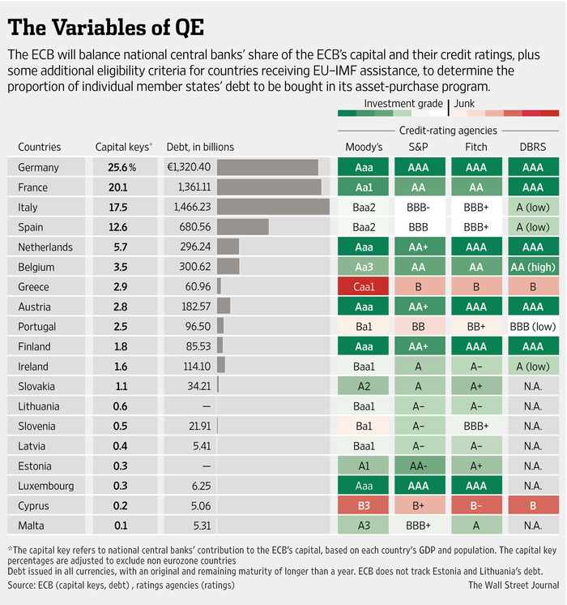ENLARGE
The decision to buy government bonds wasn’t supported by all members of the governing council. While some council members didn’t think it was necessary to buy bonds now, Mr. Draghi said there was a “large majority” in favor of launching the program and unanimity that, in principle, buying government bonds is “a true monetary policy tool.”
The agreement on the policy’s legitimacy “is the big thing,” said Mr. Annenkov. “It implicitly means that there could be more QE.”
Mr. Draghi added that there was consensus on the council in support of the decision not to share the risk of losses on the government bonds. The ECB’s monetary policy operations typically involve risk sharing, meaning any losses on securities or loans are spread throughout eurozone central banks. But Mr. Draghi said buying government bonds, particularly on such a large scale, warranted the decision to keep risks associated with government bonds largely with the individual central banks.
“We are not in a one-country setup, so the potential of fiscal transfers is there,” he said.
The bank deferred a decision on whether to purchase Greek debt, which carries a junk rating. Because the ECB bought so many Greek bonds under a previous purchase program that ran from 2010 to 2011, its holdings exceed the maximum share of a country’s debt that the ECB has set for QE. By July, enough of those bonds will have matured that the ECB could then consider adding Greece to its QE program.
The euro tumbled after the announcement, losing more than 1% against the dollar to trade at $1.1379, an 11-year low.
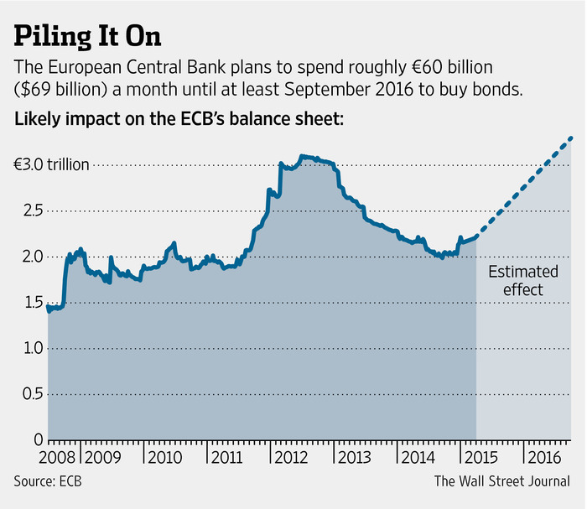ENLARGE
In volatile markets, stocks on both sides of the Atlantic were mostly higher. Bonds in the eurozone rallied, with yields on government bonds from some onetime trouble spots such as Spain hitting record lows. German government bonds, considered the eurozone’s safest market, climbed.
Denmark cut its main interest rate for the second time in a week as it sought to damp investor interest in its currency from investors selling the euro. It left its other main interest rates unchanged.
The eurozone’s $13 trillion economy, the world’s second biggest after the U.S., has failed to fully recover from the global financial crisis more than six years ago. Consumer prices fell 0.2% in December on an annual basis in the eurozone, well below the ECB’s target of just under 2% annual growth. The bloc’s unemployment rate was 11.5% in November, far higher than in the U.S. and U.K. In Spain and Greece, roughly one-quarter of the labor force is out of work.
ECB officials had sent strong signals in recent weeks that they were prepared to launch large-scale buying of government bonds. Bond yields have tumbled across the region, and the euro has declined sharply, potentially boosting exports.
With official interest rates near zero and ample loans to banks failing to boost inflation so far, the ECB was left with few options apart from buying securities in the public debt market with newly created money, thus raising the money supply.
Central banks in the U.S., U.K. and Japan used quantitative easing extensively in the aftermath of the global financial crisis. While the Federal Reserve and Bank of England haven’t extended their programs amid solid growth and falling unemployment, Japan continues to deploy QE aggressively.
Until now, the ECB has largely refrained from this measure, relying instead on interest-rate cuts and loans to banks as a means of steering new credit to the economy.
But these measures, which have also included targeted purchases of covered bonds and asset-backed securities, have failed to boost the size of the ECB’s balance sheet—the value of assets it holds—as much as officials hoped.
Still, many analysts question whether quantitative easing will work within Europe’s fragmented economy and banking system, particularly in stagnant economies such as France and Italy that have been slow to reform their labor markets to make them more flexible.
Mr. Draghi rejected any criticism that the vast expansion of the ECB’s easy-money policies would stoke inflation down the road, noting that inflation has stayed very low even after several interest rate cuts and abundant ECB loans to banks.
“There must be a statute of limitations for those who say there will be inflation,” Mr. Draghi said.
Write to Brian Blackstone at brian.blackstone@wsj.com

