Why Companies’ Results May Vary

Earnings figures differ as data providers include, and exclude, a variety of charges
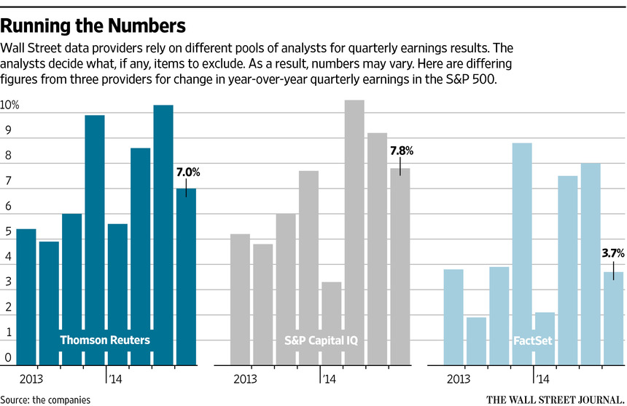
By JO CRAVEN MCGINTY, WSJ.com, April 24, 2015 5:30 a.m. ET
14 COMMENTS
Publicly traded companies are in the midst of reporting quarterly earnings, and the results will delight, pacify or rattle investors—and with good reason: Earnings per share are an important measure of corporate performance, one that sways stock prices and helps forecast growth.
But there are multiple definitions of earnings that include, or omit, different kinds of information.
Street earnings, the most coveted figures produced by Wall Street analysts and data providers, are regarded by investors as the best indicator of a company’s future growth. They also are unregulated numbers that often paint a substantially different picture than earnings prepared according to generally accepted accounting principles, known as GAAP—rules drafted to ensure companies report earnings uniformly.
GAAP earnings are recorded in financial statements to the U.S. Securities and Exchange Commission, but because they include so-called one-time items that may obscure day-to-day performance, companies and analysts also generate alternative, non-GAAP figures intended to better capture earning power.
Financial jokers refer to the non-GAAP numbers as “earnings before the bad stuff happens” because they exclude expenses GAAP requires, such as restructuring charges and asset write-downs.
Companies must report GAAP earnings, but as a matter of practice, they also will report non-GAAP earnings intended to represent performance of the core business operations by subtracting things like depreciation, marketing and administrative costs.
“This is the number the company would like investors to focus on when making decisions about whether to buy or sell shares of the company stock,” said Bryant Sheehy, director of business development for Zacks Investment Research Inc.
Non-GAAP earnings reported by companies may or may not match up with Street earnings devised by analysts, who may disagree with companies about what to preserve or remove from GAAP figures.
One isn’t necessarily better than the other, providing investors understand what the numbers represent.
“If a manager or analyst talks about earnings but ignores the write-off to goodwill, is that helpful or is that hurtful?” asked Mark Bradshaw, an accounting professor at Boston College who studies earnings. “There is a compelling argument for both.”
Amanda Sneider, a Goldman Sachs portfolio strategist, gave an example of how GAAP and non-GAAP figures may vary. The GAAP figure reported by Verizon in fourth quarter 2014 reflected a loss of 54 cents a share. The data provider Compustat, aiming to reflect the company’s core earnings, removed charges for debt retirement and other restructuring, and recorded a loss of only 41 cents per share. The Street, meanwhile, additionally removed a charge for a pension adjustment and showed a gain of 71 cents per share.
“It’s like looking at a square versus looking at a cube,” Ms. Sneider said. “It’s a different perspective of the same item. But if you look at all three, you’ll have more of an understanding of a company.”
The differing numbers also come into play when analysts try to predict how companies will perform in a given quarter. There are conventions, but analysts come up with their own adjusted estimates, and their decisions about what to include or exclude may vary from each other.
Their numbers in turn are aggregated by data providers such as FactSet, S&P Capital IQ, Thomson Reuters and Zacks, which typically produce GAAP and adjusted earnings so clients can evaluate both. Generally, the Street number represents the majority consensus of a stable of analysts tapped by each data provider.
“Let’s say 20 analysts cover a stock, and 13 do it one way and seven do it another way,” said Michael Patton, director of earnings estimates at S&P Capital IQ. “Which are in the consensus? We go by the majority rule. We go with the 13.”
The consensus figure—which is likely to vary from one provider to the next—is an average of the majority.
“It’s an average of what the analysts on the Street are submitting, what they think the company will earn,” said John Butters, an earnings analyst with FactSet.
Still, trying to reconcile the numbers can get confusing.
“It can be unclear whether a company did better or worse than the estimates,” said Gregory Harrison, an analyst at Thomson Reuters, referring to earnings estimates issued by data providers ahead of company reports.
As an example, he described a day recently when Bank of America reported 27 cents in earnings per share, while analysts had forecast 29 cents. The bank’s figure accounted for a 3-cent charge analysts hadn’t considered.
“It seemed like the estimate missed,” Mr. Harrison said. “But 3 cents were excluded, and, actually, if you back it up, they would have earned 30 cents. So they beat the estimate.”
For investors, the most important thing is to understand there are different kinds of earnings numbers, and each must be untangled to see what it is trying to highlight or play down.
“Different numbers give different information about what the company is doing,” Ms. Sneider said. “You need to know what you’re looking at.”
Write to Jo Craven McGinty at Jo.McGinty@wsj.com

