Personal Touch Makes Big Difference in Small-Business Loans

New research shows loans are less likely to end in default when borrower and lender have personal relationship
By ROBERT DEYOUNG, WSJ.com, August 24, 2015, http://www.wsj.com/articles/personal-touch-makes-big-difference-in-small-business-loans-1440381695
Want to ensure a small-business loan gets paid off? The personal touch makes a big difference.
Over the past decade, my colleagues Peter Nigro, Dennis Glennon, Scott Frame, Ken Spong and I have been looking into what makes loans backed by the Small Business Administration’s flagship 7(a) program succeed or fail. We’ve found two critical factors that both have to do with how close the lender is to the borrower.
First, when a lender does not have a personal relationship with the borrower, and instead relies strictly on credit data, the loan is more likely to end in default. Second, SBA-guaranteed loans between rural banks and rural firms in the same town are less likely to default than SBA loans between urban banks and urban firms in the same city.
Traditionally, small businesses rely on hometown lenders for credit, and for good reason: A local banker already knows many of the applicant’s colleagues, customers and associates and can more easily gather “soft information” about the applicant—details about character that don’t show up in a financial statement—and can have confidence in this information.

Right around the corner
It’s easiest to build these types of relationships in places where people are tightly knit to begin with. And that means mostly small, rural towns.
Using the concept of social capital made popular by Robert Putnam in his book “Bowling Alone,” we found that indexes of social capital—measures of participation in local life, such as civic and religious groups—are significantly higher in country towns than in urban areas.
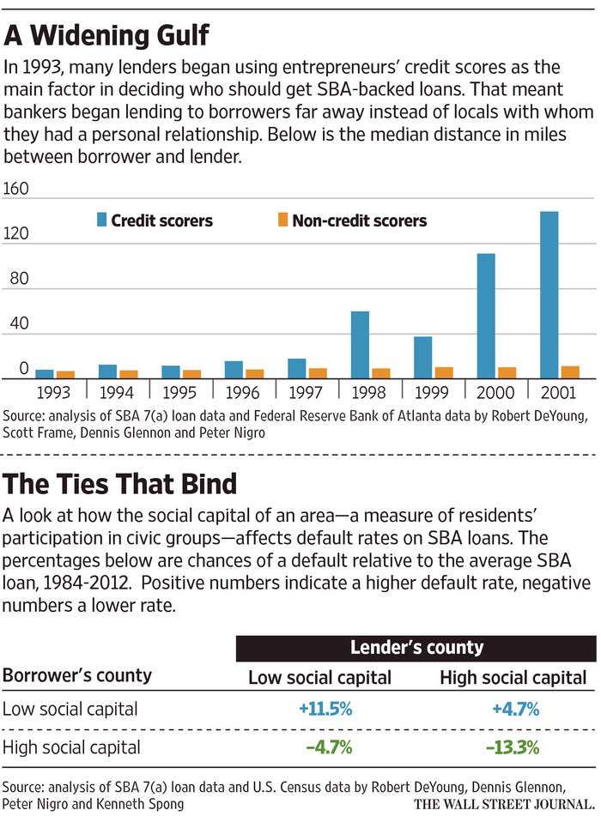 Our theory: Those tight connections make it easier for banks to gather information about borrowers, and the borrowers themselves tend to be better risks. The numbers seem to back up the idea. SBA loans between banks and borrowers in high-social-capital towns are 20% to 25% less likely to default than SBA loans made where social capital is low.
Yet the trend in the past couple of decades has been in the opposite direction—greaterdistance, both physical and social, between borrowers and lenders. During the 1990s, lenders adopted small-business credit-scoring techniques, relying solely on the hard information found in entrepreneurs’ personal credit scores, rather than on personal relationships. It was an appealing setup for lenders and borrowers alike. The banks got to target potential customers much farther away than before, and small businesses no longer had to rely on hometown lenders.
The downside was that default rates soared—because using only hard information provides an inferior picture of small-business creditworthiness. By our estimates, SBA loan-default rates for credit-scoring banks were 23% higher (22% vs. 18%) than SBA loan-default rates for banks that used more-traditional methods. (For comparison, less than 2% of non-SBA business loans default.)

The local touch
Of course, lenders that use credit scoring can rake in profits even if default rates soar because it costs much less to gather information. The government also covers part of the loss if the borrower can’t pay.
But ensuring that bank lenders earn profits is not the goal of small-business policy. Whenever an SBA-backed loan ends in default, it costs taxpayers money, and we are already pouring a tremendous amount into the 7(a) program—$19.2 billion in 2014. The SBA can best execute its mission by working with banks that lend to struggling small businesses without generating high loan-default losses.
Dr. DeYoung is Capitol Federal Distinguished Professor and director of the Center for Banking Excellence at the University of Kansas School of Business. He can be reached atreports@wsj.com.

