EEC 4268 Activity Lesson Plan Guideline

Please add details on (1) how you will talk to, question and encourage the children, (2) how you will model the activity for the children, and (3) what language you will use to assess the children!

Introducing the activity

1. Connect the activity to previous knowledge or experiences.
2. Pre-assess the children’s content knowledge.
3. Give children an opportunity to contribute and connect
4. Provide a hands-on experience for the children

Teaching Content Knowledge for the activity

5. Tell the children about the activity
6. Give clear expectations
7. Pre-teach any content vocabulary or concepts
8. During Activity Assessments: Check for comprehension of new vocabulary/concepts

Modeling the activity

9. Clearly restate expectations.
10. Create a step-by-step process that you will model
11. Create a step-by-step instruction as you go (for children to refer to when they work on their own)
12. During Activity Assessments: Frequently check for child understanding as you model the activity
13. Show the finished product to the children and review expectations

Transition

14. State a specific way you will help the children transition to seats (or next step)
15. State if you will be grouping children intentionally based on ZPD

Independent Practice

16. State how you will be modeling children’s progress
17. Provide examples of how you will scaffold children’s independent practice
18. Post-Assessment: Describe how you will evaluate the children’s product

Example Language for Activity Lesson Plans

Objectives-Goals:
The student will be able to…
→ _Recognize a rhyming pair from the read-aloud story
→ _Produce a rhyme during the extension activity

Concept Planning/Scaffolding:
1) Prompt Students to recall what the book “Pete the Cat and the Missing Cupcakes” was about: “Can you describe what happened in the book we just read?”
2) Prompt students to think about rhyming pairs.
- “You were asked to feed Pete the Cat a cupcake when you heard something. What were you listening for?”
☼ Correct answer is rhyming pairs or rhyming words
- “Can you tell me what a rhyming pair is? I forgot!”
☼ Correct answer is words that end with the same sound like pat and cat.
☼ If students struggle to answer this, help model by saying “I think pat and cat have the same ending sound, does this mean they’re a rhyming pair? Yes it does! Pat and cat are a rhyming pair.”
3) Tell students that we are going to play a game about rhyming pairs!

Lesson Steps/Procedure: (Engage, Explore, Explain, Elaborate, Evaluate) BEFORE LESSON/ ENGAGE:
- To start the lesson, first model what is expected each “round” of the game.
  - Lay out all of the cupcakes on the table.
  - Pick up one cupcake and say what picture is on it. (EMPHASIZE THE ENDING SOUND)
  - Pick up another cupcake and say what picture is on it (EMPHASIZE THE ENDING SOUND)
  - Repeat both words one after the other, with emphasis on the final sound. Then say
“Hm, are these words a rhyming pair?”.
  - Model both of the following: one rhyming pair and one non-rhyming pair.
→ “Yes because they end with the same final sound”
→ “No because they end with different sounds.”
If the two words are a rhyming pair, put the two cupcakes together and then place them off to the side.
- Now that you have modeled what to do, help The students complete one match (scaffold).
  - Ask The students, “Go ahead and pick up one cupcake. What is on it?”
  - “Now, grab another cupcake. What is on that one?”
  - Compare the two words by over-annunciating each final sound. Repeat the words and say, “Do these words end with the same sound?”
→ “Yes because they end with the same final sound”
→ “No because they end with different sounds.”
  - Be sure to encourage The students to repeat after you when you are saying each word.
  - Repeat this scaffolded step as many times a needed, until The students seems comfortable and confident solving a match on her own!
- Ask The students to complete a match on her own (independent practice).
- While The students are attempting to solve a match on her own, make note of the ones she matches correctly and the ones she matches incorrectly.
- If she matches an incorrect pair, over-annunciate the word with the students and have them echo/repeat the final sounds. Help her understand that if they sound the SAME at the end, they are a rhyming pair. If they are DIFFERENT at the end, they are NOT a rhyming pair.
AFTER LESSON/ ELABORATE/ EVALUATE:
- After the students have attempted to match all the rhyming pairs, go over each one by doing the following:
  - Pick up a rhyming pair.
  - Say both words with emphasis on the final sound and have the students repeat/echo you.
  - “These two words are rhyming pairs because they have the same final sound”
- Now that she has had the opportunity to solve on her own and with scaffolded help, its time to assess her understanding through a quick review.
  - Hold up two random cupcakes and say, “Do these two words rhyme?”
o Have the students say the words by herself without your help. You can point to each picture on the cupcake to prompt her response, but do not verbally say each word.
  - Record her answer for that rhyming pair here:
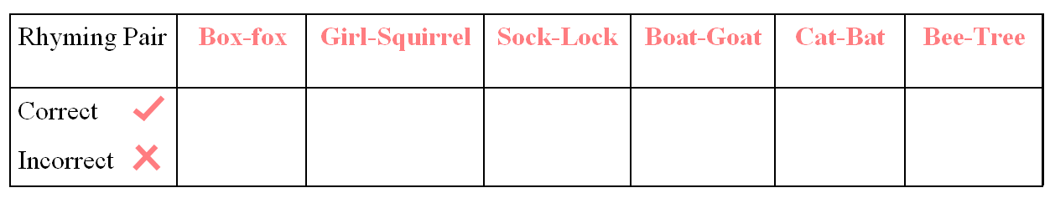
The students will be assessed based on how many rhyming pairs she correctly identifies. This comes from the Phonological Awareness Skills Test (P.A.S.T). A score that shoes mastery of rhyme recognition is a 5/6.

