STUDIO
UNIT 8
RAY OPTICS
PHY 2054 COLLEGE PHYSICS II

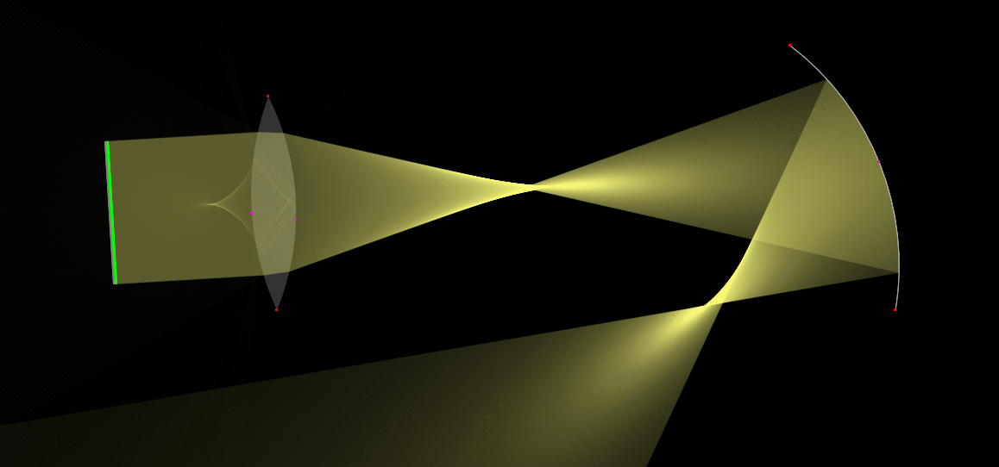

Objectives:

- To understand and apply ray model of light

- To understand the refraction of light at interfaces

- To understand the refraction of light when travelling in different medium

Introduction:

A light ray is a line in the direction along which energy of light is flowing. Light rays can bounce, or reflect, off a surface. Specular reflection is the reflection from a smooth, shiny surface such as a mirror or a piece of polished metal.

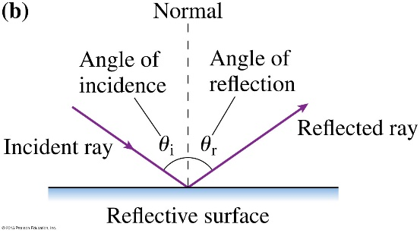
θ_{r} = θ_{i}

When light rays incident at the surface of a transparent medium, part of the light continues into the second medium. It is transmitted rather than reflected, but the transmitted ray changes direction as it crosses the boundary. The transmission of light from one medium to another, but with a change in direction, is called refraction.

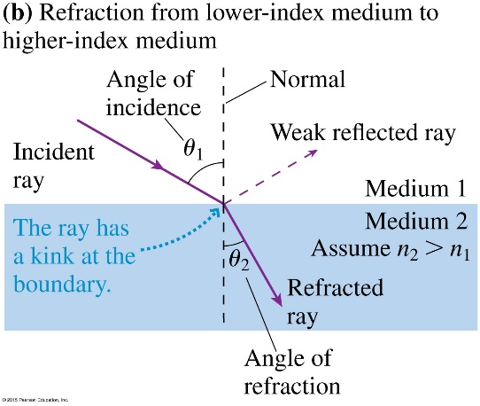
n₁ sin θ₁ = n₂ sin θ₂

Procedure:
Part A: Reflection and Refraction
Download the Bending Light simulation via the following link
https://phet.colorado.edu/en/simulation/bending-light
Select ‘Intro’. The interface should look like following. Play with the simulation and get familiarize yourself with the tools there.
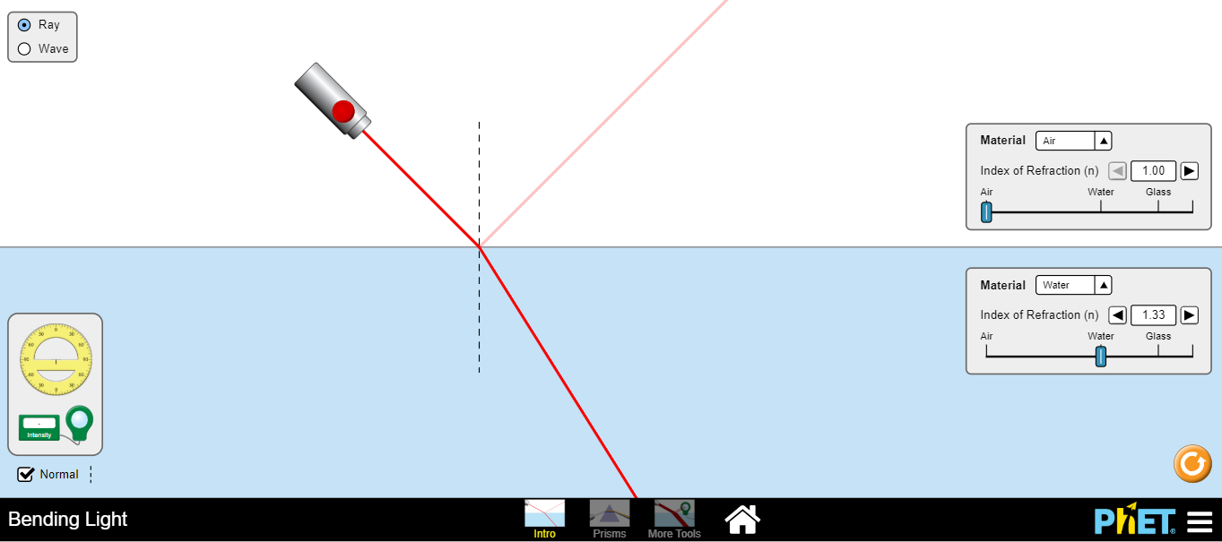

Q1. Observe what happens to the reflected and refracted rays when you change the angle of incidence. Keep the Material 1: Air and Material 2: Water. Measure and record the angles of reflection and refraction for the given angles in the table.

Angle of Incidence (θ₁) | Angle of Reflection (θr) | Angle of Refraction (θ₂)
20º
40º
60º
80º

Q2. Propose a method to find refractive index of water using the above data. (Hints: the graph of sin θ₂ vs sin θ₁ is linear, you can use Excel to plot and find the slope of linear graphs)
Please write down the procedure here.

Q3. Find the refractive index of water using the proposed method. Please show necessary graphs/calculations here.

Q4. Now change the first material to water and second material to air. With your knowledge in refraction, find the critical angle of water-air boundary.

Part B: Lenses
Download the Geometric Optics simulation via the following link
https://www.physicsclassroom.com/Physics-Interactives/Refraction-and-Lenses/Optics-Bench/Optics-Bench-Refraction-Interactive
Q5. The focal points of the lens are marked with the crosses on the optical axis. Move and place the object at the focal point. What happens to the refracted rays? Where is the image formed?

Q6. Place the object at a distance about twice the focal length. You can select the ruler from the top panel to measure the distance accurately. Where is the image formed? Measure and record the distance to the image from the lens.

Q7. Qualitatively, report here the properties of the image (upright/inverted, enlarged/reduced, real/virtual) formed in the previous step.

Q8. What happens to the image when you place the object at a distance shorter than the focal length? List the image properties here.

