STUDIO
UNIT 7
INTERFERENCE AND
DIFFRACTION OF LIGHT
PHY 2054 COLLEGE PHYSICS II

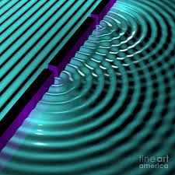

Objectives:

- To understand the wave nature of light

- To understand the interference of light due to a double silt

- To understand the diffraction of light due to a single slit

Introduction:

Light consists of very rapidly oscillating electric and magnetic fields. It is an electromagnetic wave which travels at a speed c = 3.00 x 10⁸ m/s in vacuum. Visible light wavelengths range from 400 nm–700 nm. This is the visible spectrum.
Because light acts as a wave, light waves can overlap and interfere constructively and destructively. Here, we use two slits to observe this phenomenon.
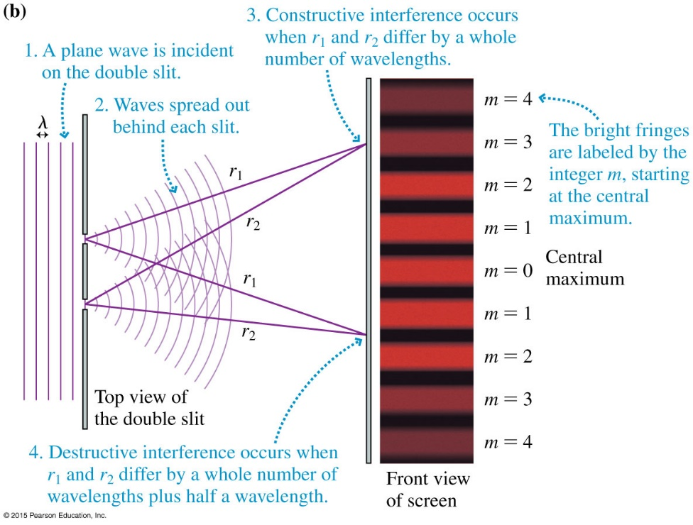
In this experiment, if the path difference ($∆r=\left|r_{1}-r_{2}\right|$) is an integer multiple of wavelength (λ) we can see a bright fringe on the screen which is due to constructive interference of the two wave fronts. Following are some important equations.
The dark fringes are due to destructive interference where $∆r=\left(m+\frac{1}{2}\right)λ$
The wave spreads out to fill the space behind the opening. This phenomenon is called diffraction. Diffraction becomes noticeable when the opening is comparable in size to the wavelength of the wave.

Procedure:
Part A: Wave nature of light
Download the wave interference simulation via the following link
https://phet.colorado.edu/en/simulation/legacy/wave-interference
Select ‘Light’ from the top panel of the simulation. The interface should look like following. Play with the simulation and get familiarize yourself with the tools there.

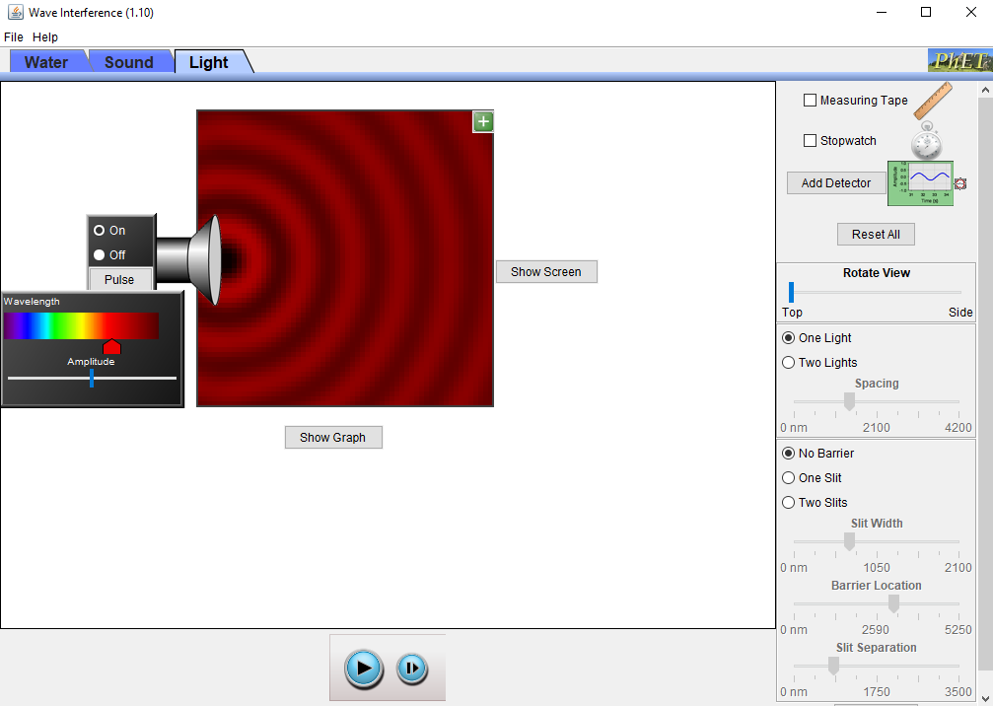

Q1. Does the frequency change when you change the wavelength of light in the simulation? (you can add a detector to observe E-field vs. Time graph at any point) Explain why.

Q2. With the sources and tools you have in the simulation, design an experiment to find the speed of light. Write down the procedure, measurements and any necessary calculations here.

Part B: Double slit interference
Introduce two slits to the simulation (place it around the center of the field) and observe the intensity on the screen. You can also add a graph to see the intensity pattern (Show ScreenIntensity Graph). Clear interference pattern can be seen if you set the amplitude to be maximum and wavelength to be shorter (e.g. Blue light).
Screen shot and paste your simulation display here.

Q3. What differences do you observe here in the light intensity on the screen compared to the single light source? With your knowledge in the wave superposition, describe why this intensity variation occur.

Q4. What happens to the intensity pattern on the screen when you change the wavelength of light?

Q5. What happens to the intensity pattern when the slits are brought closer (smaller slit separation) and farther (larger slit separation) apart?

Q6: Measure the distance between two maxima. Record the value here.

Q7. What factors may affect this distance? Discuss.

Q8. Using the measured value in Q6 and other relevant measurements, calculate the wavelength of incident light.

Part C: Single slit diffraction
Replace the two slits with one slit. Observe and record the intensity pattern on the screen here.

Q9. Compare the intensity pattern on the screen with the double slit experiment. What differences can you observe?

Q10. Change the slit width and observe how the intensity changes. Write down your observations here.

Q11. Based on your observations in Part B and Part C, built your own definitions for interference and diffraction. What are the differences between them? Can you say interference and diffraction are properties of waves? Why or why not?

