STUDIO – Unit 6

PHY2054 College Physics II

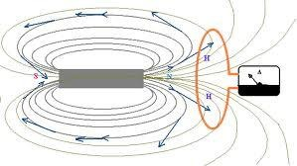

[FARADAY’S AND LENZ’S
LAWS]
FARAD AY’S LAW AND LENZ’S LAW

Objectives

to understand how a changing magnetic field can give rise to a current to understand the concept of magnetic flux
to understand qualitatively and quantitatively (Faraday’s Law) that a changing
magnetic flux gives rise to an emf
to understand the direction of a current set up by a changing magnetic field
(Lenz’s Law)

Equipment:
1 stack magnet set
1 NS marked magnet
1 small coil
1 analog ammeter/galvanometer

1.1
The coil that we will be using in this experiment is shown in the following diagram and
the specifications follow. We will use the outer coil in this experiment.

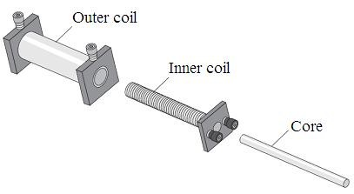Specifications:
Small Coil: 235 turns, #18 wire approx. 1mm,
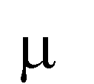inductance: 78 ± 22 H. resistance: 0.4 ± 0.1Ω, capacitance: 142±2pF.
Dimensions: 12cm coil length X 1.7cm coil outside diameter.
Base: 5cm X 5cm.
Larger Coil: 2920 turns, #29 wire: approx. 0.29mm, inductance: 63 ±3mH, resistance: 76 ±2 Ω, capacitance: 124 ±2pF.
Dimensions: 11 cm coil length X 3.5cm coil outside diameter.
Base: 5cm X 5cm.
Core: 16.5cm X 0.8cm.
Ratio of turns: 12.4:1.
Ratio of voltage: approximately 10:1.
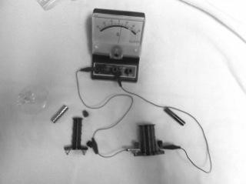The following photographs show the actual setup:

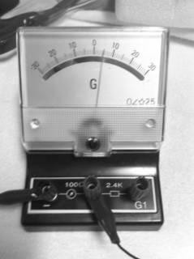Use the center post connection.

Connect the larger diameter coil to the analog ammeter/galvanometer, as shown in the diagram below. Be aware of what direction a current will flow through the galvanometer for a positive and a negative (- to +) current direction through the meter. (Discuss how to do this with your instructor.)

The Stack Magnet:

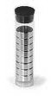

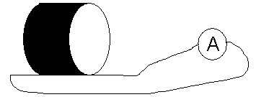Coil
a. Take the stack magnet and move it back and forth near the loops of wire. Observe the ammeter while the magnet is moving. The weird looking diagram represents a wire that starts at one end and goes through the coil. It includes an Ammeter represented by the circle with an “A” in it.

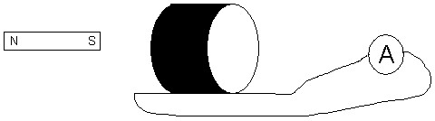

Put the north pole toward the loop. Then put the south pole toward the loop. Record your observations. Include the 4 possible cases: ( N or S pole into the coil or out of the coil).

REPEAT for the magnet inserted on the other end of the coil.

COMPARE the two observations

REPEAT with the smaller coil and note any significant differences.

b. Hold the magnet still near the coil. Record your observations.

c. Using the data from above, tabulate the direction of flow of positive charge through the wire based on the ammeter reading for each case:

north pole moves toward the loops north pole moves away from the loops south pole moves toward the loops south pole moves away from the loops

Left End: Magnet Motion Direction | Direction of current (indicated by meter)
Right End: Magnet Motion Direction | Direction of current (indicated by meter)

d. Does the current depend on the speed with which the magnet is moved towards or away from the coil? Explain.

e. The current in the coil is called the induced current because it is brought about by a changing magnetic field through the coil. There is no battery in the circuit. Yet, charges are moving through the wire. There must be a force doing work on the charges. Further experiments show that the charges are moving because they are in an electric field. The electric field is in the wire! The changing magnetic field is creating an electric field. The work done per unit charge by the electric force is called the emf, sometimes designated
as ε, If more work is done per unit charge, the current is larger. The emf and the current are related by ε = emf = IR.

The rate at which charges move through the wire seems to depend on the motion of the magnet. Further experiments (which we will not do) reveal that the amount of current in the wire depends on:

the time rate of change of magnetic flux
the number of loops (turns) in the wire

The magnetic flux is defined the same way as the electric flux, but in terms of the magnetic field and the area, instead of the electric field and the area:

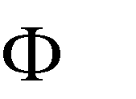A cos 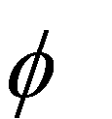
B

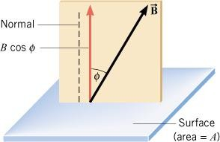

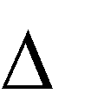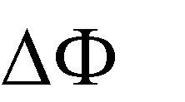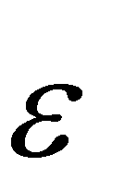The equation for the emf for a wire with N turns is then:
t
N

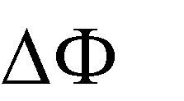where N is the number of turns in the wire, is the time rate of change of magnetic flux. This equation is called Faraday’s Law.
t

The direction the current flows through the loop is such that the current in the loop will set up a magnetic field to oppose the change in flux through the loop. This is called Lenz’s Law.

If the north pole of the magnet is moving toward the loop, the flux through the loop is increasing, the current through the loop would set up a magnetic field in the opposite direction as the magnetic field produced by the north pole of the magnet in order to decrease the flux through the loop.

If the north pole of the magnet is moving away from the loop, the flux through the loop is decreasing, the current through the loop would set up a magnetic field in the same
direction as the magnetic field produced by the north pole of the magnet in order to increase the flux through the loop.

e. Determine the direction that current flows through the loop when the south pole of the magnet moves toward the loop and when the south pole of the magnet is moved away from the loop. Note the direction of the windings (L→R or R→L).

WITHOUT LOOKING BACK AND WORKING ALONE, what are the most significant things that you learned in this unit? Do not be sarcastic.

SUMMARY

Lenz’s Law: Whenever there is an induced electromotive force (emf) in a conductor, it is always in such a direction that the current it would produce would oppose the change which causes the induced emf. If the change is the motion of a conductor through a magnetic field, the induced current must be in such a direction as to produce a force opposing the motion. If the change causing the emf is a change of flux threading a coil, the induced current must produce a flux in such a direction as to oppose the change.

Lenz's law is a form of the law of conservation of energy, since it states that a change cannot propagate itself.

You should understand that a changing magnetic field can give rise to a current. You should also understand the concept of magnetic flux. You should understand qualitatively and quantitatively (Faraday’s Law) that a changing magnetic flux gives rise to an emf. You should understand the direction of a current set up by a changing magnetic field (Lenz’s Law).

