MIPS Reference Sheet
Instruction Formats
R-Type
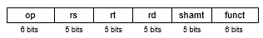
I-Type
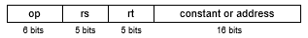
J-Type
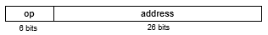
Available Registers
Temporaries: $t0-t9 Return Values: $v0, $v1
Saved Values: $s0-$s7 Return Address: $ra
Arguments: $a0-$a3 Stack Pointer: $sp
Instructions
add add $1,$2,$3 $1 = $2 + $3
subtract sub $1,$2,$3 $1 = $2 – $3
add immediate addi $1,$2,100 $1 = $2 + 100
shift left logical sll $1,$2,10 $1 = $2 << 10
shift right logical srl $1,$2,10 $1 = $2 >> 10
store word sw $3, 8($4) Mem[$4+8]=$3
load word lw $1, 8($2) $1=Mem[8+$2]
load upper imm lui $1,40 $1 = 40 << 16
set less than slt $1,$2,$3 $1 = ($2 < $3)
set less than imm slti $1,$2,100 $1 = ($2 < 100)
Branch on equal beq $s1, $s2, L if (s1 == s2), go to L
Branch on !equal bne $s1, $s2, L if (s1 != s2), go to L
jump j 10000 PC = PC:40000
jump register jr $31 PC = $31
jump and link jal 10000 $31 = PC + 4; PC = 40000

