In-Class Active Learning Exercise:
Viruses, prokaryotes and microbial eukaryotes

Introduction:
There are different types of microbes, such as viruses, bacteria, protists and fungi. They are simply all around us. Microbes live in the soil, on rocks, inside roots, buried under miles of Earth, in compost piles and toxic waste, and all over the Earth's surface. They are found in boiling hot springs and on frozen snowfields, but also live in homes, in schools and on statues. You name it, it will likely have some sort of microbe on it. Even you are covered in microbes! Some live on your skin, while others make up your gut microbiome.

Real-world application:
Being everywhere, micro-organisms (or microbes for short) play very important roles in our lives, which makes it essential that we study them. Many microscopic organisms play a key role in maintaining life on earth, fixing gases and breaking down dead plant and animal matter into simpler substances that are used at the beginning of the food chain. A few harmful microbes, for example less than 1% of bacteria, can invade our body (the host) and make us ill. Others are again used to help in the production of many food items, making medicines, keeping the environment clean, in manufacturing and in research.

Objectives:
- Understand how viruses function and make use of their hosts
- Distinguish between prokaryotic binary fission and conjugation
- Understand the significance of the various steps of endosymbiosis theory
- Describe fungal form and function
- Explain the various steps of the fungal life cycle

Preparation related to the two assignments on this worksheet:
- Read Chapters 21, 22, 23.1 and 24
- Answer the pre-lecture questions on Chapters 21, 22, 23.1 and 24
- Attend the lectures on Chapters 21, 22, 23.1 and 24 and actively participate in iClicker questions

Grading:
You have ~25 minutes to work through this worksheet in small groups.
Afterwards, you’ll get 10 iClicker questions that you will have to answer individually.
Each question is worth 1 point: 0.75 point for the correct answer and 0.25 point for an incorrect answer
These points contribute to your overall iClicker score, which is 5% of your final grade.

Assignment 1: Viral Replication (~7 mins)
Viruses are nonliving intracellular parasites that infect plants, animals, and bacteria. Viruses use host cell components to make copies of themselves. Often, but not always, the process of viral replication kills the host cell.

1A Virus structures.
Sort the items according to whether they may be found only in free virus particles, only in uninfected host cells, or in both viruses and host cells.
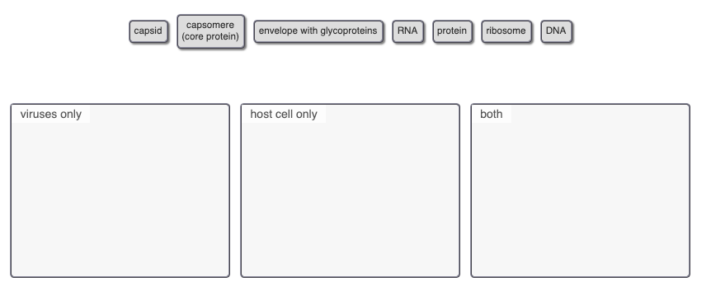

1B Reproductive cycles of a bacteriophage
Classify each phrase as applying to the lytic cycle, the lysogenic cycle, or both types of reproductive cycles of phages.
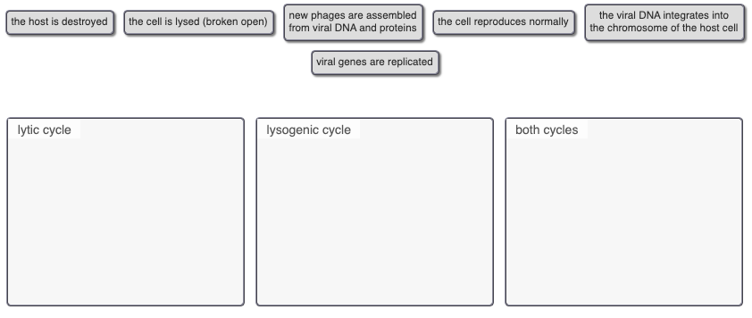

1C Virus properties
Select the four statements about viruses that are true.

- HIV contains two identical strands of DNA.
- All viral genomes contain both DNA and RNA.
- HIV contains reverse transcriptase.
- The capsid enters the host cell if the virus is enveloped.
- All RNA-containing viruses are retroviruses.
- Enveloped viruses bud from the host cell.
- A retrovirus contains RNA.

1D Why is it ineffective to treat viral disease with antibiotics?

- Pathogenic RNA viruses have a high rate of mutation, producing new genetic varieties that are insensitive to antibiotic treatment.
- Antibiotics inhibit enzymes specific to bacteria and have no effect on virally encoded enzymes.
- Due to excessive antibiotic use, most viruses have evolved to be resistant to antibiotics.

Assignment 2: Bacterial Conjugation and Binary Fission (~10 mins)
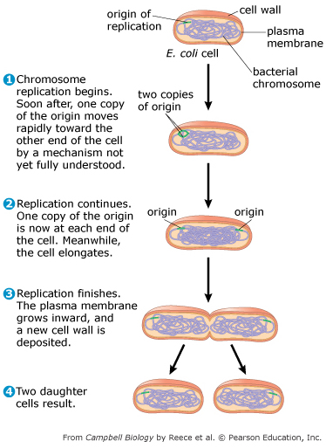
Genetic variation is crucial to natural selection and evolution, and the great success of bacteria is due, in part, to the extensive genetic variation found in bacterial populations. This genetic variation exists despite the fact that bacteria reproduce asexually.

This figure shows how bacteria reproduce through binary fission.

2A Combine the terms on the left with the appropriate blanks on the right to complete the sentences.
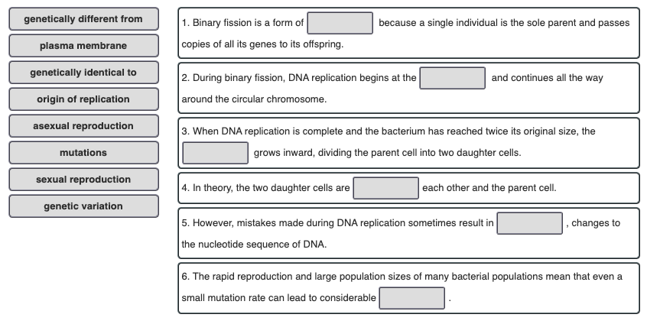

2B Bacterial conjugation
Because bacteria reproduce asexually, each organism typically obtains its genetic material from only one parent. However, bacteria do have mechanisms for bringing together DNA from different individuals. One of these mechanisms is bacterial conjugation, a process that results in the direct transfer of genetic material from one bacterium to another.
The figure shows two examples of bacterial conjugation. In these examples, bacteria with a segment of DNA called an F factor are able to initiate conjugation.
- An F factor is a piece of DNA that contains about 25 genes.
- Most of the genes in the F factor are related to the production of a structure called a mating bridge. The mating bridge links two bacterial cells during conjugation, allowing for DNA transfer.
- The F factor may be found on a separate piece of DNA called an F plasmid, shown in part (a) of the figure. Or it may be found within the main bacterial chromosome, shown in part (b) of the figure.

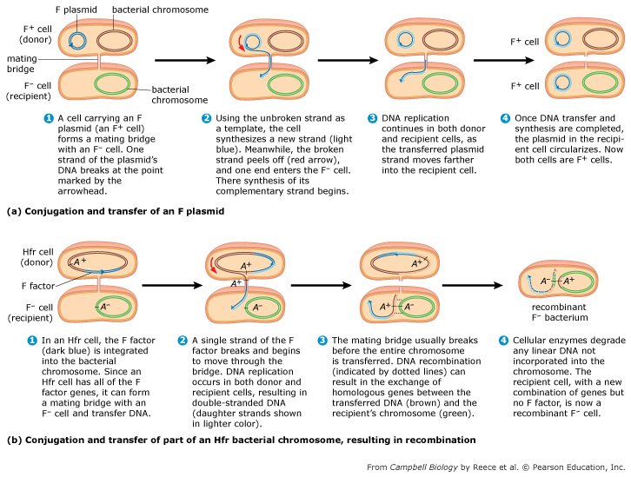

Combine each phrase with the appropriate bin depending on whether it applies to an F⁺ cell, an Hfr cell, or an F– cell. (Remember that we are only considering conjugation involving the F factor here, and not other mechanisms for transferring genetic material.)

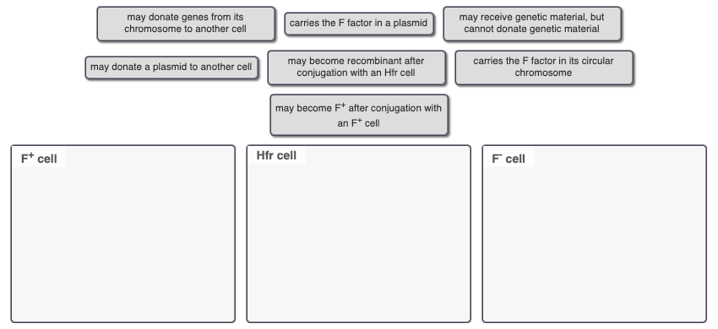

2C How do binary fission and conjugation contribute to the spread of antibiotic resistance in bacteria?
The asexual reproduction of bacteria (i.e., binary fission) may seem to suggest that all bacterial cells within a population should be the same. Yet bacterial populations possess considerable genetic variation. You have seen that two significant sources of genetic variation in bacteria are:
- mutations that arise during DNA replication
- genetic exchange during bacterial conjugation
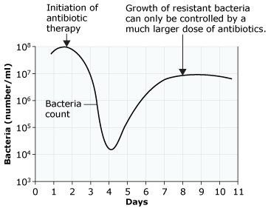
Genetic variation has allowed many bacteria to evolve resistance to antibiotics, and conjugation plays a particularly important role in the spread of antibiotic resistance from one bacterial species to another.
Like the F plasmid, the R plasmid (R stands for “resistance”) may allow bacteria to initiate conjugation. The R plasmid contains genes for antibiotic resistance. During conjugation, the R plasmid and its antibiotic-resistance genes are transferred from the donor cell to the recipient cell.
The graph shows how antibiotic resistance can develop in a patient with a bacterial infection. Notice that the bacteria count drops when antibiotic therapy is started, but then rises again as resistance spreads through the population.

Combine the labels with their appropriate locations on the concept map below to explore the links between antibiotic resistance, binary fission, and conjugation.

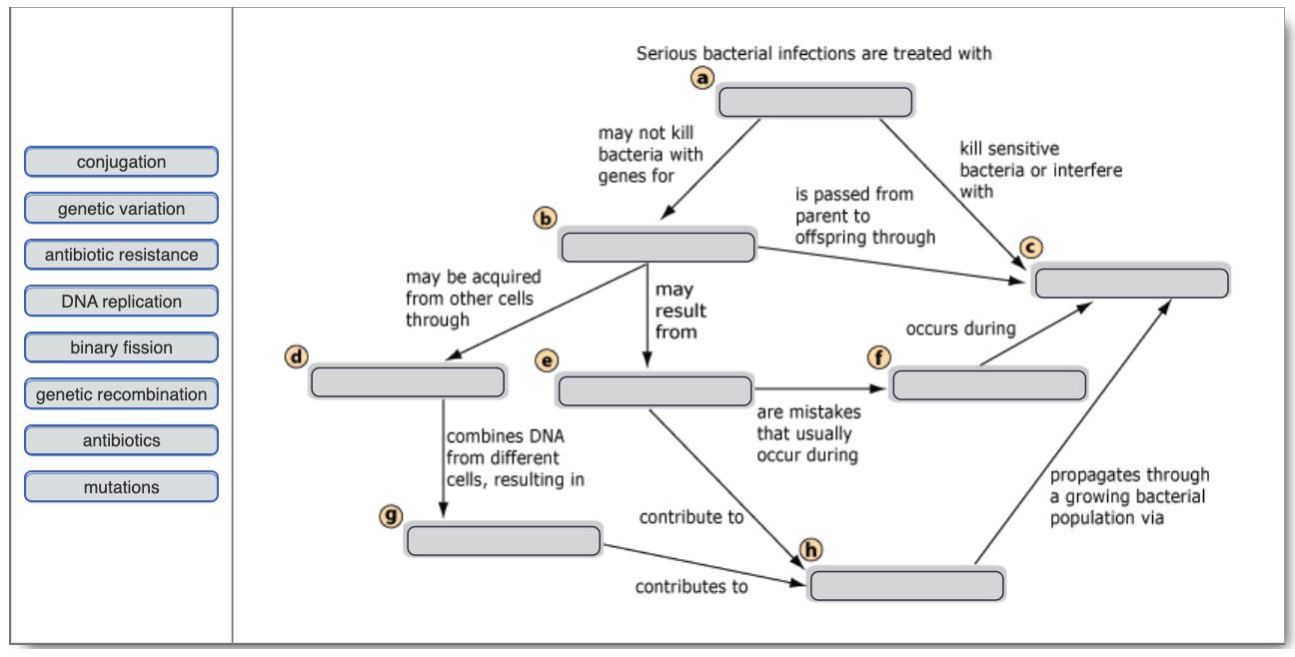

Assignment 3: The Serial Endosymbiosis Theory (~3 mins)

3A In the origin of the eukaryotes, endosymbiosis….
- is thought to explain the origin of the nucleus.
- describes the engulfing of a photosynthetic bacterium that ultimately gave rise to mitochondria.
- most likely began with a heterotrophic endosymbiont entering the cell as undigested prey or as an internal parasite.
- most likely began with the endosymbiont entering the host cell through the endomembrane system.

3B During the origin of the eukaryotic cell, it is thought that engulfed bacteria….
- had a mutually beneficial relationship with their hosts initially, but later evolved to become harmful to their hosts.
- were always harmful to their hosts.
- did not initially have a mutually beneficial relationship with their hosts, but later evolved one.
- always had a mutually beneficial relationship with their hosts.

3C Which of the cells shown in the figure are eukaryotic cells?
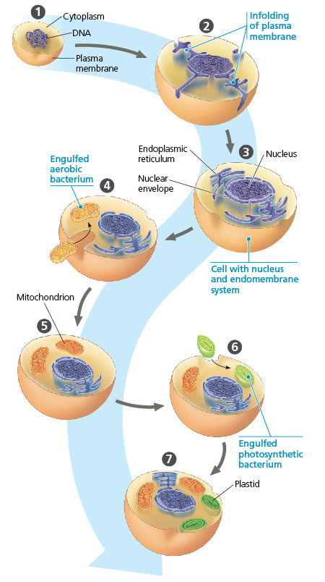
- 3 and 4
- 6 and 7
- 5, 6, and 7
- 4, 5, 6, and 7

Assignment 4: Fungal Morphology, Nutrion and Life Cycle (~5 mins)
Multicellular fungi share some key traits, including their body structures, growth patterns, and methods for absorbing nutrients. However, although their feeding methods may be similar, fungal species differ markedly in their sources of nutrients, which include both living and dead organisms. As a result, fungi play a variety of roles in ecological communities.

4A Structure of multicellular fungi
This diagram shows the structure of a multicellular fungus, with an expanded view of two types of hyphae. Identify the structures and determine which hypha is septate and which is coenocytic. (Note that although this diagram shows the two types of hyphae, a fungus can have either one type or the other, but not both.)
Combine the labels with their appropriate locations on the diagram of the fungus and hyphae below.
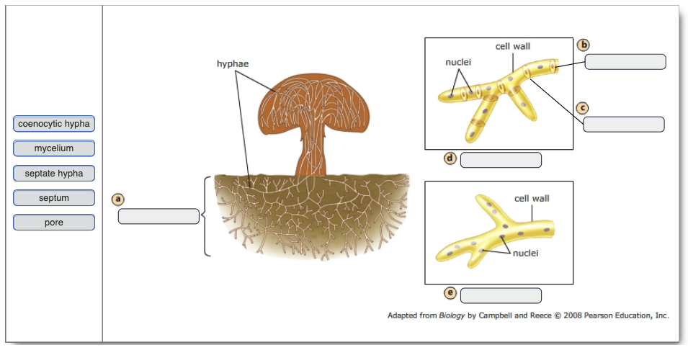

4B Ecological interactions of fungi
Most fungi are decomposers; they recycle the nutrients from nonliving organic matter. Other fungi are specialized to live in symbiotic relationships with other organisms. Some fungi live as parasites and others as mutualists. Most plants, in fact, could not survive and grow without their fungal partner.

This table lists some examples of different fungal strategies for obtaining nutrients.

Fungus | Nutrition
Septobasidium spp. | Fungal hyphae penetrate a living scale insect's body and absorb its nutrients. The individual insect that serves as the food source is immobilized, but the rest of the insect colony benefits from the shelter the fungus provides.
mycorrhizal fungi on  pine tree roots | Mycorrhizal fungi associate with roots and receive carbohydrates from the pine tree. The tree receives phosphorus, and may die without this association.
fungi in the family Lepiotaceae | Leaf-cutter ants cultivate fungal gardens that consist of fungi in the family Lepiotaceae. The ants feed and care for the fungi,and the fungi serve as a food source for the ants.
Cordyceps spp. | Spores from these fungi attach to insects. The mycelium grows into the insect's body and absorbs nutrients from the soft tissues. Eventually the fungus sends up its reproductive structure through the insect's head.
Trichophyton spp. | Trichophyton is one genus of fungi responsible for athlete's foot, ringworm, and jock itch. The fungi colonize the outer skin layer and utilize keratin as their food source.
coprophilous fungi | These fungi absorb nutrients from animal feces.
Cryphonectria parasitica | C. parasitica absorb nutrients after breaking down the cells of living chestnut trees, causing chestnut blight.

Sort the following fungi based on whether they are decomposers, mutualists, or parasites.

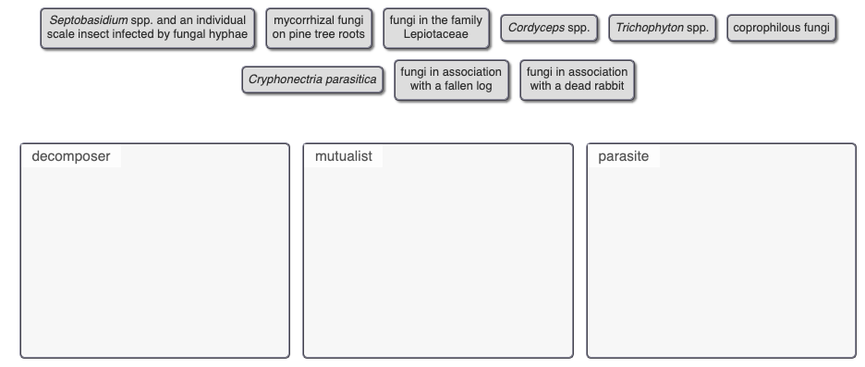

4C Fungal Life Cycles
Fungi produce _____ spores.
- dikaryotic
- heterokaryotic
- haploid
- diploid
- triploid

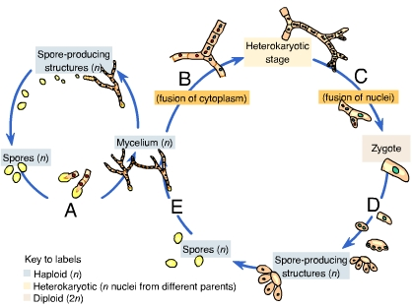
Karyogamy produces a _____.
- diploid zygote
- haploid zygote
- spores
- mycelium
- hypha

Plasmogamy is indicated by the letter _____.

Which of these contains two haploid nuclei?
- the heterokaryotic stage of the fungal life cycle
- zygote
- spore-producing structures
- mycelium
- hypha

