Module Outline

Module Title

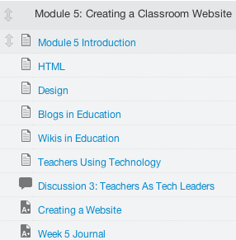

Introduction

Content

Assessment

Module Title

Add a title here.

Introduction Page

This page contains a brief introduction to the topic covered in the module. This can be in a narrative or audio/video format (be mindful of students in your course who may require special accommodations). This page also contains your objectives for the module.

Module Objectives
List the objectives for this module
- Objective 1
- Objective 2
- Objective 3

Content/Activities

What type of student to content interaction will your students have? Depending on the resource, it may be in a <Replace – Your LMS> page or directly linked from the module table of contents.
- Textbook readings
- Text written by the instructor
- Website links
- Links to journals/newspapers
- Videos
  - YouTube
  - 3rd party video
    - Movie/TV
    - Documentary
  - Instructor created video
- Audio
  - 3rd party audio
  - Instructor created
- PDFs
- Images
- Word/PowerPoint/Excel

Assessment

List the assessment(s) strategy that will be used to determine whether the learning objectives have been met (e.g., quiz, essay, discussion, group project). Provide specific directions for students in the area provided for each assignment, for example:

Introduction Discussion Posting
Describe the activity in a brief paragraph within the activity itself
Provide specific steps in order to complete the activity

